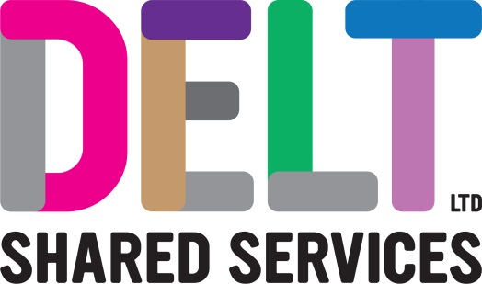

ROLE PROFILE

|  |  |
| --- | --- |
| **Role Profile** | |
| **Job Title** | Learning & Organisational Development (L&OD)Coordinator |
| **Department** | Workforce & Brand |
| **Reports to** | Chief People & Culture Officer |
| **Location** | Combination of office & remote working Building 2, Derriford Business Park, Plymouth |

|  |  |
| --- | --- |
| **Job Purpose** | The L&OD Coordinator will play a key role with the co-ordination, planning and administration of people initiatives across the L&OD and HR Team; acting as a first point of contact for all queries ensuring a responsive and customer focused service |
| **Key Competencies and Output** | Responsibility for the coordination and administration of a range of learning and organisational development activities and projects as directed by the Chief People & Culture Officer as well as ensuring the development and maintenance of robust learning and development systems and processes including but not limited to:   * corporate induction coordination * training administration * performance management reporting * wellbeing initiative   Takes ownership of all administration of the learning and wellbeing platforms including running reports, uploading users, assigning training modules, and removing users as required.  Coordination of external training courses including researching costs.  Consistently maintains and updates relevant training records to ensure GDPR compliance is met.  Works with the HR team to drive the outcomes/objectives of the Health and Wellbeing plan across the Company.  General administration/coordination duties, including managing room bookings, sending correspondence, organising refreshments, etc.  Supports the wider HR team and Recruitment Business Partner with any ad hoc relevant projects.  The accountabilities listed here are not an exhaustive list. The post holder will be required to work in any area of the business and deliver ad-hoc duties as and when directed. |
| **Experience, Knowledge, Skills and Qualifications** | Proven experience in an administration or coordination focused role.  Experience applying initiative, solving problems and being solution focussed.  Confidence in using Microsoft Office products: Outlook, Word, Excel and PowerPoint.  Demonstrable strong technical capability and proficiency with LMS system administration.  Strong communication skills and the ability to inspire confidence in customers from the advice given and commitment to task.  Ability to manage and organise workload and be comfortable in a team or working alone.  Self-motivated, positive, and enthusiastic growth mindset.  The flexibility and willingness to work outside of core hours where necessary to deliver against the requirements of the role. |
| **Corporate Standards** | In accordance with Delt’s organisational policies and guidance on information management and security, it is the personal responsibility of all employees to ensure data protection, client confidentiality and appropriate information governance.  All employees must act at all times in accordance with appropriate legislation and regulations, codes of practice and Delt’s policies and procedures.  All employees must work with the requirements of our Health and Safety policy, ensuring safe systems of work and procedures.  Undertake all duties with regard to the Delt equalities policy and relevant legislation.  In a ‘people first’ environment, the post holder must both be aligned and aspire to Delt’s values and expected standards of behaviour for them and their team(s). |