ROLE PROFILE

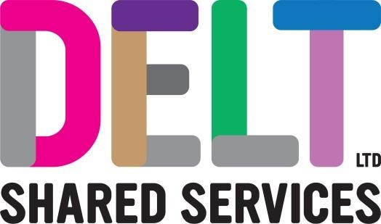

|  |  |  |  |
| --- | --- | --- | --- |
| **Role Profile** | | | |
| **Job Title** | Network & Telephony Engineer | | |
| **Section** | Connectivity and Communications | **Department** | Infrastructure |
| **Reports to**  **(Job Title)** | Connectivity and Communications Service Owner | | |
| **Location** | Plymouth | | |

|  |  |
| --- | --- |
| **Job Purpose** | This role is responsible for the delivery of service using Connectivity and Communication Services which DELT offer our customers.  As a Network and Telephony Engineer you will be responsible for support & maintenance of systems within DELT infrastructure services and the completion of project activities. You will complete tasks with autonomy within the defined standards and procedures but also support the ongoing improvement of the connectivity and communication services provided by DELT to it’s customers |
| **Key**  **Competencies and Output** | Is Network & Telephony Engineer for DELT and our customers in a complex and multi-tenant environment. Plays a key part in the infrastructure department ensuing that our Infrastructure service is Secure, Available, Flexible and Efficient.  Contributes to the successful delivery of infrastructure projects. Autonomously delivering small & medium sized projects across the Connectivity and Communication Services, and assisting senior engineers or technical architects in the delivery of larger, more complex projects  Ensures Risks or Issues in the delivery of these competencies are clearly documented and either mitigated or accepted working with the Connectivity and Communication Service Owner  Produces relevant documentation and maintains asset registers / configuration management database accordingly.  Works closely with senior network & telephony engineers, service owner and technical architect to feed relevant information into project plans & proposals, change & release management, designs.  Leads any alteration of configuration in live environments through change governance providing implementation, backout and test plans alongside technical risk assessment.  Undertakes maintenance activities including patching, backup whilst exploiting automation opportunities where possible and considering customer availability requirements.  Defines and documents “runbooks” for residual, manually completed tasks to support BAU or project activities that are easy to follow and have a high level of accuracy.  Provides effort estimates for work to service owner or technical architect where required.  Monitors systems for capacity & availability, security, and support events, and undertakes remedial action whilst escalating issues where required to the technical architect and product owner.  Resolves incidents within service level agreements, using agreed procedures and providing documented fixes for future use or preventative measures to prevent reoccurrence.  Understands core IT technologies and keeps abreast of new technology trends  Supports more junior members of the team in their technical skill development.  The accountabilities listed here are not an exhaustive list. The post holder will be required to work in any area of the business and deliver ad-hoc duties as and when directed |

|  |  |
| --- | --- |
| **Experience, Knowledge, Skills and Qualifications** | Demonstrable experience in the following:   * Enterprise Network technologies such as SD-WAN (Fortinet), Proxy, Firewall (Checkpoint) and protocols such as BGP or at a minimum demonstrable experience in working with similar technologies in an enterprise environment * Access layer technologies such as Cisco Meraki for wired and wireless connectivity or at a minimum demonstrable experience in working with similar technologies in an enterprise environment * Enterprise telephony technology such as Avaya or Teams, or at a minimum willingness to learn within 12 months * Development of documentation for systems to be followed by more junior staff members * Experience working within an ITIL environment. * Project delivery in an enterprise environment * Troubleshooting and problem solving in an enterprise environment * Experience engaging with customers (internal or external) on projects or support   **Desirable qualifications**  • ITIL foundation  • Relevant technical qualifications at an administrator level |
| **Corporate Standards** | In accordance with Delt’s organisational policies and guidance on information management and security, it is the personal responsibility of all employees to ensure data protection, client confidentiality and appropriate information governance.    All employees must act at all times in accordance with appropriate legislation and regulations, codes of practice and Delt’s policies and procedures.    All employees must work with the requirements of our Health and Safety policy, ensuring safe systems of work and procedures.    Undertake all duties with regard to the Delt equalities policy and relevant legislation.    In a ‘people first’ environment, the post holder must both be aligned and aspire to Delt’s values and expected standards of behaviour for them and their team(s). |