ROLE PROFILE

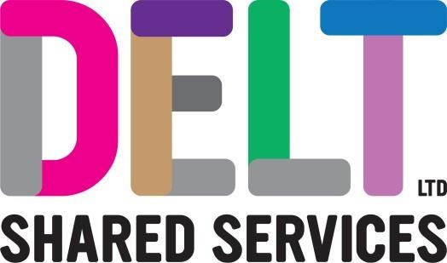

|  |  |  |  |  |  |
| --- | --- | --- | --- | --- | --- |
| **Role Profile** |  | |  |  | |
| **Job Title** | Apprentice Estates Maintenance | |  |  | |
| **Section** | Estates | | **Department** | Business Support | |
| **Reports to (Job Title)** | Operations Manager | |  |  | |
| **Suitable for Job Share (Y/N)** | No | | **If no, state reason** | Requirement to provide a consistent service to customers | |
| **Location** | Various | | **Shift Pattern** | Office hours as per company terms and conditions | |
| **Core Technical Competencies/Skills and Knowledge/ Understanding** | | | A Property Maintenance Operative will use their knowledge and understanding of basic carpentry, electrical, plumbing and decorating to;   * Understand and demonstrate the importance of Health and Safety in the workplace * Comply with organisational safety, policies and procedures and identify hazards and reduce them * Consider safety compliance with a diverse sector of client groups * Understand and demonstrate the importance of working safely at height * Carry out repairs to the fabric of a building, for example repairs to walls, doors, doorframes, skirting boards or plaster damage to internal walls * Understand and maintain plumbing and drainage systems, for example repairs to WC systems, leaking taps or water testing and unblocking drains * Maintain high levels of water hygiene within a building * Understand and maintain electrical distribution, safe repair of electrical installation to legal requirements, for example replacing damaged sockets, plugs, lighting and fuses. * Understand and maintain plant, safety systems and equipment * Demonstrate and implement energy, environment and sustainable practices * Understand and maintain grounds and external fabrication of a building, such as drainage and guttering * Understand and demonstrate the safe use of hand tools, for example screwdrivers, power drills, pliers, paper strippers and a variety of other tools used in plumbing and carpentry * Demonstrate and understand the importance of the control of resources and stock * Understand and demonstrate the principles of Planned Preventative Maintenance * Understand how to prepare for refurbishment or deep clean of equipment and surfaces * Carry out repairs and reactive maintenance * Understand the importance of customer service * Record and report information accurately either internally or externally | | |

|  |  |
| --- | --- |
| **Core Behavioural Attributes** | * Have a flexible attitude * Commitment to quality and excellence * Ability to perform under pressure * Persists in the face of adversity * Thorough approach to work * Ownership of work and follow through to a satisfactory conclusion. * Client/Customer focus and interaction * Able to live the organisations values * Ability to create effective working relationships * Aptitude for problem solving * Ability to comply with company policies and procedures * Enthusiasm * Ability to control and influence within remit * Persuasive influencing skills * Shows respect for all stakeholders |
| **Interpersonal Skills** | * Take ownership of situations * Work independently and as part of a team * Communicates effectively either verbally or in writing * Problem solving approach * A drive for efficiency and value for money * Communicate effectively at all levels * Adaptability * Ability to understand limitations within the role * A drive for quality and excellence * Enhanced DBS |
| **Corporate Standards** | In accordance with Delt’s organisational policies and guidance on information management and security, it is the personal responsibility of all employees to ensure data protection, client confidentiality and appropriate information governance.    All employees must always act in accordance with appropriate legislation and regulations, codes of practice and Delt’s policies and procedures.  All employees must work with the requirements of our Health and Safety policy, ensuring safe systems of work and procedures.    Undertake all duties with regard to the Delt equalities policy and relevant legislation.    In a ‘people first’ environment, the post holder must both be aligned and aspire to Delt’s values and expected standards of behaviour for them and their team(s). |