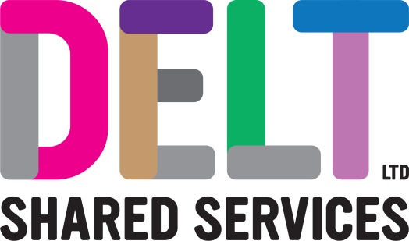
ROLE PROFILE

Role Profile
Job Title | Junior Applications Analyst
Section | Applications | Department | Infrastructure & Applications
Reports to  (Job Title) | Application Team Lead
Location | Building 2 Derriford Business Park

Job Purpose | The Junior Application Analyst will have the ability to undertake day to day operational activities in the ICT applications portfolio, whilst making sure customer service level agreements are met and maintained.  Helps deliver the ICT Application Service in the most effective and efficient way and in accordance with ICT strategy, technology architecture, best practice and industry standards.
Key Competencies and Output | Carries out Application investigations and resolution of technical issues; helping to maintain the Applications portfolio by delivering upgrades whilst following the correct procedures and gateways.  Works independently in solving technical issues or identifying technical solutions, while providing excellent face to face customer service  Works with colleagues and customers to ensure compliant services are delivered.  Follows policies, plans and strategies relating to ITIL Incident, problem, change, configuration, capacity and availability.  Follows policies relating to project and programme governance, including resourcing and time recording.  Provides estimates for work required by the customer under supervision of a more senior engineer or manager.  Carries out risk assessments as part of change management including assessing, implementing and testing changes; working to reduce risk of service failure  Provides technical advice to Delt customers to a high-level standard to maximise their understanding.  Liaises with customers to ensure system maintenance will be prioritised to have the least impact.  Undertakes quality checks to ensure procedures are followed.  Reviews and update procedures when necessary and keep technical documentation accurate and current.  Works and integrates with the rest of the Applications Service across all teams, such as Infrastructure and Security.  Works to agreed Service Level Agreements and meet or exceed Key Performance Indicators  Keeps abreast of new technology trends and developing solutions in the applications arena  The accountabilities listed here are not an exhaustive list. The post holder will be required to work in any area of the business and deliver ad-hoc duties as and when directed
Experience, Knowledge, Skills and Qualifications | Hold an IT related degree or have the equivalent level of experience; ITIL Foundation V 3 or later  Experience in creating, documenting and delivering IT solutions which address user needs  Exposure to or understanding of PCI-DSS or Public Sector Security standards and security remediation  Knowledge and understanding of Microsoft 365 technologies including Teams, Sharepoint, Azure, security roles and user management.  Knowledge or experience of agile application development – design, development, testing, deployment  Knowledge and proven understanding of multiple ICT areas encompassing 1st, 2nd and 3rd Line support in an ITIL environment.  Understanding of complex system integration (API’s, SSIS)  Application Deployment technologies (AppV, SCCM)  Appreciation of different software licensing and delivery models  Fundamental understanding of different databases and RDBMS setups – particularly SQL Server.  Significant and demonstrable experience with PowerShell, BASH or equivalent  Knowledge or Experience of working with a CMS product (e.g. Firmstep / Drupal) or developing web applications  Exposure and moderate experience of various data and reporting tools (e.g. Crystal Reports, SSRS)  Proficient user in a range of Microsoft packages.
Corporate Standards | In accordance with Delt’s organisational policies and guidance on information management and security, it is the personal responsibility of all employees to ensure data protection, client confidentiality and appropriate information governance.  All employees must act at all times in accordance with appropriate legislation and regulations, codes of practice and Delt’s policies and procedures.  All employees must work with the requirements of our Health and Safety policy, ensuring safe systems of work and procedures.  Undertake all duties with regard to the Delt equalities policy and relevant legislation.  In a ‘people first’ environment, the post holder must both be aligned and aspire to Delt’s values and expected standards of behaviour for them and their team(s).

