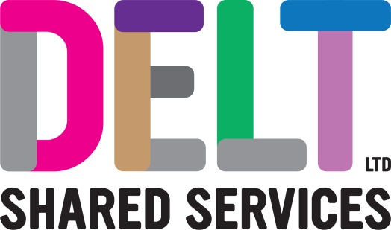
ROLE PROFILE

Role Profile
Job Title | Infrastructure Engineer
Section | Infrastructure & Operations | Department | Infrastructure
Reports to  (Job Title) | Operations Bridge or Infrastructure Projects

Job Purpose | The postholder will undertake day-to-day investigation / resolution of technical incidents and BAU activities of the IT network infrastructure, ensuring Service Level Agreements (SLAs) are met and that infrastructure security and compliance guidelines are achieved.  To contribute to the successful delivery of Infrastructure projects. Autonomously delivering small & medium sized projects across the Infrastructure portfolio. Assisting senior engineers in the delivery of larger complex projects
Key Competencies & Output | Delivers the IT Infrastructure Service in the most effective and efficient way, in accordance with IT strategy, technology architecture, best practice and industry standards.  Delivers discrete packages of work and wider projects across a multi-tenanted estate.  Delivers detailed, high and low level, technical designs that articulate decisions and rationale; Including, assisting in and producing associated ROMs for technical elements.  Works to corporate processes and procedures, developing and maintaining the knowledge base for the service. Reviews and updates procedures when necessary and keeps technical documentation accurate and current.  Follows policies, plans and strategies relating to ITIL incident, problem, change, configuration, capacity and availability.  Follows policies relating to project and programme governance, including resourcing and time recording.  Carries out risk assessments and quality checks as part of change management including assessing, implementing and testing changes to reduce risk of service failure.  Provides technical advice to Delt’s customers to maximise their understanding.  Provides estimates for work required by the customer.  Works with various stakeholders to ensure performance of the infrastructure is maximised.  Works to agreed Service Level Agreements (SLAs) and meets or exceed Key Performance Indicators (KPIs).  Understands core IT technologies, keeping abreast of new technology trends and developing solutions in the infrastructure discipline.  The accountabilities listed here are not an exhaustive list. The post holder will be required to work in any area of the business and deliver ad-hoc duties as and when directed
Experience, Knowledge, Skills and Qualifications | ITIL v3 Foundation level.  Demonstrable experience working in a professional, customer-focused, ITIL environment.  Experience working with technical project delivery, liaising with project manager and 3rd parties.  Experience of working with switching / routing and managing firewalls in an enterprise environment.  Knowledge of, or experience in:  - Microsoft Server products (in a commercial setting)  - Working with virtual host solutions  - Storage and Compute technologies  - Scripting – Powershell or other platforms  - Microsoft APP-V / RDS / terminal services / thin client delivery  - Access Control Management  - Client VPN Solutions  - Active Directory  - Group Policy  - DHCP / DNS  - Microsoft Exchange Server 2010-2016  - LAN / WAN technologies  - WiFi (Cisco / Aruba / Meraki)  - Web Proxy technologies  - Infrastructure Security  - Network VPNs  - Load Balancing  - Cloud Based services, e.g. Microsoft Azure and Office 365  - VoIP services  A good working knowledge of infrastructure hardware, topology and configuration.  Committed to personal and professional development.  A full UK driving licence.
Corporate Standards | In accordance with Delt’s organisational policies and guidance on information management and security, it is the personal responsibility of all employees to ensure data protection, client confidentiality and appropriate information governance.  All employees must act at all times in accordance with appropriate legislation and regulations, codes of practice and Delt’s policies and procedures.  All employees must work with the requirements of our Health and Safety policy, ensuring safe systems of work and procedures.  Undertake all duties with regard to the Delt equalities policy and relevant legislation.  In a ‘people first’ environment, the post holder must both be aligned and aspire to Delt’s values and expected standards of behaviour for them and their team(s).

