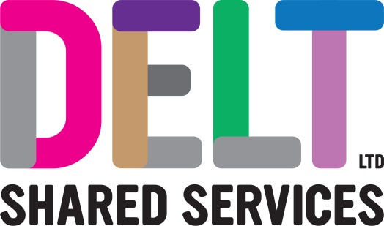
ROLE PROFILE

Role Profile
Job Title | IT Field Engineer
Section |  | Department | Field Engineering Team
Reports to  (Job Title) | Field Engineering Team Leader
Location | Delt Office

Job Purpose | Undertake the day-to-day technical support for Delt Shared Services. Deliver technical resolution for Delt Services to ensure customer Service Level Agreements are met and that security and compliance guidelines are followed.  Ensure desktop services are maintained for all Delt’s customers.  To provide exceptional customer service to maximise the satisfaction of the service users.  Commission, test, deliver and install new IT equipment throughout the supported estate including relocating existing equipment and/or data where identified.  Co-ordinate work with system suppliers as required to ensure the smooth running of customers systems.  Analyse, identify, and resolve problems associated with all IT hardware/software, networks and connections.  Carry out day-to-day investigation and resolution of technical incidents.  Provide specialist technical advice regarding Incident Management and Request Fulfilment in a complex and diverse multi-site organisation, with various client requirements from both public and private sector customers.
Key Competencies and Output | To decide on the best course of action to resolve IT Support Incidents.  To create, use and review standard IT procedures, recommending improvements as technologies and processes change in line with best practice and compliance standards.  Respond to incoming transactions from telephone calls, email, IM, and other methods to resolve service issues, and deliver service requests to the agreed standard.  Provide advice on which solution is the most appropriate, recommending a course of action, ensuring that recommendations are consistent, supportable and that documented standards are achieved.  Deliver the IT Support and Request Fulfilment Service in the most effective and efficient way and in accordance with IT strategy, technology architecture, best practice, and industry standards.  Work to corporate processes, procedures and develop and maintain the knowledge base for the Service.  Work with colleagues and customers to ensure compliant services are delivered.  Carry out installations, fixes and decommission activities in line with agreed procedures and DSE requirements.  Participate in relevant internal and external working groups/projects to provide information/analyst advice and support and to maintain data collection systems for its effective use by the team.  Responsible for updating the CMDB (Configuration Management Database) with all hardware and software changes to maximise accuracy of records.  Follow policies, plans and strategies relating to ITIL Incident, Problem, and Change Management.  Follow policies relating to project and programme governance, including resourcing and time recording.  To have an understanding of core IT technologies.  To prepare, monitor and report on IT statistical information, embedding the Service management culture.  Work to reduce risk of service failure.  Develop and maintain professional networks to benefit the Organisation.  To provide technical advice to Delt’s customers to maximise their understanding.  Liaise with customers to ensure system maintenance will be prioritised to have the least impact.  Review and update procedures when necessary and keep technical documentation accurate and current.  Work to agreed Service Level Agreements and meet or exceed Key Performance Indicators.  To keep abreast of new technology trends and developing solutions in the Server and storage arena.  Undertake other reasonable duties as requested by organisation managers.  The accountabilities listed here are not an exhaustive list. The post holder will be required to work in any area of the business and deliver ad-hoc duties as and when directed
Experience, Knowledge, Skills and Qualifications | Essential  5 GCSEs to include English and Math’s, or relevant work experience.  Relevant IT qualification for example MCP, SDI, CompTIA, CCNA or a commitment to study.  Demonstrable experience of working in a professional environment within at least 2 of the following:  Incident Management  Request Fulfilment  Problem Management  Configuration Management  Experience of working autonomously and as part of a team.  Experience of working in a customer focused IT environment.  Proficient user in a range of Microsoft packages.  A willingness to undertake appropriate and regular training as required.  Commitment to personal and professional development.  Knowledge and experience of working in a 1st & 2nd Line support IT Support role.  A full UK driving license  Desirable  ITIL foundation  Knowledge & experience of working within a 3rd Line support role  Working knowledge of Office365, Intune & Cloud Storage  Interpersonal and communication skills for working with a range of colleagues, stakeholders, and partners.  Analytical skills and a creative approach to problem solving.  The ability to show initiative when dealing with issues and to take steps to ensure the issue is resolved in a timely manner.  Ability to apply risk management techniques to IT service management.  Customer care skills are required to deliver an excellent customer focused IT service.  The ability to prioritize work, based on urgency and impact to the end user.  Keyboard and telephony skills with considerable demand for precision to ensure accurate information is recorded.
Corporate Standards | In accordance with Delt’s organisational policies and guidance on information management and security, it is the personal responsibility of all employees to ensure data protection, client confidentiality and appropriate information governance.  All employees must act at all times in accordance with appropriate legislation and regulations, codes of practice and Delt’s policies and procedures.  All employees must work with the requirements of our Health and Safety policy, ensuring safe systems of work and procedures.  Undertake all duties with regard to the Delt equalities policy and relevant legislation.  In a ‘people first’ environment, the post holder must both be aligned and aspire to Delt’s values and expected standards of behaviour for them and their team(s).

