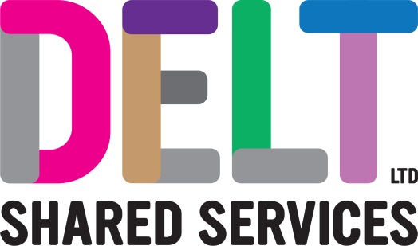
ROLE PROFILE

Role Profile
Job Title | Desktop Engineer
Section | End User Computing | Department | Infrastructure & Operations
Reports to  (Job Title) | End User Computing Manager
Location | Building 2, Derriford Business Park, Plymouth

Job Purpose | The postholder will provide enterprise support to multiple large tenants at several sites across the Southwest. The role will involve managing and administering the technology and tools used to provision and support end user devices throughout their lifecycle.
Key Competencies and Output | Delivers and supports Windows Desktop OS, associated component and applications.  Delivers the End User Computing Service in the most effective and efficient way, in accordance with ICT strategy, technology architecture, best practice and industry standards.  Delivers and supports various MDM platforms.  Delivers discrete packages of work and wider projects across a multi-tenanted estate.  Provides technical evaluation, testing and deployment of new technologies, software, and services.  Provides estimates for work required by the customer.  Manages, configures, and deploys the end user computing environments utilising toolsets such as Microsoft SCCM, Intune, O365, Azure, Active Directory, Group Policy, App-V and PowerShell.  Provides technical leadership for Delt staff and its customers, across existing processes, new customer work, and project engagements.  Keeps abreast with industry trends, product life cycles and roadmaps to provide appropriate recommendations.  The accountabilities listed here are not an exhaustive list. The post holder will be required to work in any area of the business and deliver ad-hoc duties as and when directed
Experience, Knowledge, Skills and Qualifications | A minimum of Microsoft MCP, MCTS (or equivalent level of experience).  ITIL v3 Foundation level.  Demonstrable experience working in a professional, customer focused, ITIL environment.  Demonstrable experience of working in a desktop management role within a complex ICT environment along with excellent knowledge of desktop, laptop and mobile device hardware, operating systems and protocols.  Experience working with technical project delivery, liaising with project manager and 3rd parties.  Experience of relevant Microsoft technologies including the following:  - Microsoft Windows OS  - Microsoft SCCM  - Microsoft Intune  - App Packaging (App-V, Scripted Installs, MSI)  - Group Policy Objects  Committed to personal and professional development.  A full UK driving licence.
Corporate Standards | In accordance with Delt’s organisational policies and guidance on information management and security, it is the personal responsibility of all employees to ensure data protection, client confidentiality and appropriate information governance.  All employees must act at all times in accordance with appropriate legislation and regulations, codes of practice and Delt’s policies and procedures.  All employees must work with the requirements of our Health and Safety policy, ensuring safe systems of work and procedures.  Undertake all duties with regard to the Delt equalities policy and relevant legislation.  In a ‘people first’ environment, the post holder must both be aligned and aspire to Delt’s values and expected standards of behaviour for them and their team(s).

