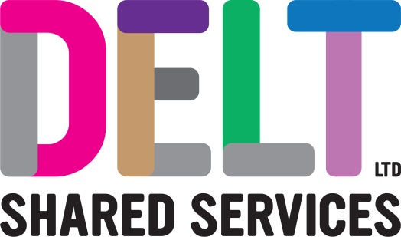
ROLE PROFILE

Role Profile
Job Title | Project Manager
Department | Project Management Office
Reports to | Lead Project Manager
Location | Building 2, Derriford Business Park, Plymouth

Job Purpose | Manage all aspects of project management in a Portfolio, Programme and Projects environment to support Delt’s partners and customers deliver strategic priorities.  This may involve work managing all stages of Project lifecycle from concept through to transition and benefits realisation.  You will work to deploy the most appropriate delivery model to balance time, quality and risk to achieve maximum efficiency, effectiveness and customer focus.  Projects will vary in size, complexity and stakeholders. They will encompass infrastructure, software implementation, and shared services in on premises, partnership and system as service offerings.
Key Competencies & Outputs | Gathers internal and external stakeholder requirements and works in collaboration with specialist functions within Delt, procurement, HR and architects to develop appropriate proposals and quotes with detailed project plans including milestones, resourcing requirements, risks and costs.  Ensures delivery working with the customer, external suppliers and Delt team in a matrix management structure. Working collaboratively with resource managers within Delt to secure resources within cost, time and quality expectations.  Monitors and maintains key information reporting on the status of all projects and provides project visibility to sponsors and Delt PMO using reporting tools, exception reports and via other governance structures such as project boards.  Manages project risk and issues using project reporting tools and escalations routes engaging with stakeholders, PMO and Portfolio holders as required.  Actively participates in project audit and quality reviews.  Manages the change control of the project gaining agreement for revisions to time, cost, quality or delivery specification with project sponsors and business system owners.  Ensures that projects are transitioned in a managed way to operational teams and reviewed with shared knowledge, captured lessons learned and appropriate documentation.  Undertaking final analysis of projects closure with the Delt specialist areas, sponsor and or customer to ensure project sign off.  Support and or manages business benefits realisation as appropriate to the project delivery.  Participates and supports delivery of process improvements based on project delivery performance working in liaison with the PMO Manager and leads.  Provides project management expertise to other projects to ensure the smooth implementation of the entire portfolio.  Ensures projects are developed in accordance with the sponsors priorities and in line with the broader Delt IT strategy and technical roadmap.  Works in a professional capacity engaging with specialist services as required and maintaining ethical standards and legal compliance.  The accountabilities listed here are not an exhaustive list. The post holder will be required to work in any area of the business and deliver ad-hoc duties as and when directed.
Experience, Knowledge, Skills and Qualifications | Excellent interpersonal skills, able to build and foster collaborative working relationships with internal and external stakeholders.  Excellent written and verbal communications skills for delivery of workshops, business cases, board reporting and tailoring documentation and material to meet the needs of the audience.  Able to analyse and structure information to make evidence-based decisions.  Demonstrable planning and organisational skills with risk and issue management.  Demonstrable experience of managing projects in a complex organisation – across multiple sites, at scale, and or at pace, meeting quality expectations.  Demonstrable experience managing resources to ensure projects are delivered on time to quality and to budget. Being able to work in both face to face and remote managed environments.  Demonstrable experience working in a professional IT environment using ITIL based assurance processes and customer management systems.  Demonstrable experience in effective transition.  Knowledge of business change and business benefits management techniques and experience.  Able to develop and foster an environment for creative solutions to solve problems.  Able to work in environments where there are competing priorities.  Experience of using MS Project and Project Online or Project Server.  A relevant project management qualification (e.g. Prince 2, APM, PMI)  Degree or equivalent level of experience.  Commitment to personal and professional development.
Corporate Standards | In accordance with Delt’s organisational policies and guidance on information management and security, it is the personal responsibility of all employees to ensure data protection, client confidentiality and appropriate information governance.  All employees must always act in accordance with appropriate legislation and regulations, codes of practice and Delt’s policies and procedures.  All employees must work with the requirements of our Health and Safety policy, ensuring safe systems of work and procedures.  Undertake all duties with regards to the Delt equalities policy and relevant legislation.  In a ‘people first’ environment, the post holder must both be aligned and aspire to Delt’s values and expected standards of behaviour for them and their team(s).

