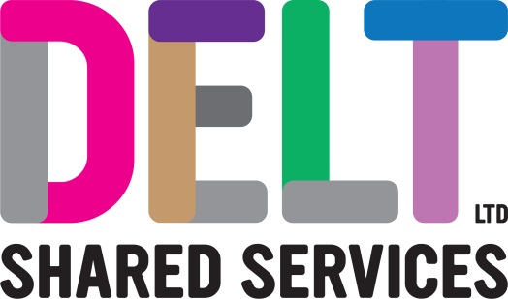
ROLE PROFILE

Role Profile
Job Title | IT Technician
Section |  | Department | Client Services
Reports to  (Job Title) | Client Services Team Lead
Location | Delt Offices

Job Purpose | Undertakes the day to day 1st and 2nd Line Support for Delt Shared Services and its customers. Deliver 1st Line Services to ensure Customer Service Level Agreements are met and that security and compliance guidelines are followed. Providing exceptional customer service to maximise the satisfaction of the service users.
Key Competencies and Output | Delivers an IT 1st and 2nd Line Support, Reactive and Proactive incident and Request Fulfilment Service in the most effective and efficient way and in accordance with IT strategy, technology architecture, best practice and industry standards.  Works to corporate processes, procedures and develop and maintain the knowledge base for the Service. Review and update procedures when necessary and keep technical documentation accurate and current.  Works with colleagues and customers to ensure compliant services are delivered.  Carries out, installations, fixes and decommission activities in line with agreed procedures and DSE requirements.  Participates in relevant internal and external working groups/projects to provide information/analyst advice and support and to maintain data collection systems for its effective use by the team.  Responsible for updating the CMDB (Configuration Management Database) with all hardware and software changes to maximise accuracy of records.  Provides ITSM administration for the Delt toolset as agreed.  Follows policies, plans and strategies relating to ITIL incident, request fulfilment, problem, configuration and change management.  Follows policies relating to project and programme governance, including resourcing and time recording.  Keeps abreast of new technology trends to ensure an understanding of core IT technologies.  Prepares, monitors and reports on IT statistical information, embedding the Service management culture.  Works to reduce risk of service failure.  Provides advice on which solution is the most appropriate, recommending a course of action, ensuring that recommendations are consistent, supportable and that documented standards are achieved  Provides technical advice to Delt’s customers to maximise their understanding.  Works to agreed Service Level Agreements and meet or exceed Key Performance Indicators.  Responds to incoming transactions from telephone calls, email, IM and other methods to resolve service issues, and deliver service requests to the agreed standard.  The accountabilities listed here are not an exhaustive list. The post holder will be required to work in any area of the business and deliver ad-hoc duties as and when directed
Experience, Knowledge, Skills and Qualifications | 5 GCSEs Grade A*-C to include English and Maths, or relevant work experience.  Microsoft Certified qualification  ITIL foundation  Service Desk Institute Analyst or higher  Demonstrable experience of working in a professional environment or 1st Line IT support role within at least 2 of the following;  - Incident Management  - Request Fulfilment  - Problem Management  - Configuration Management  Experience of working in a customer focused IT environment.  Works under pressure with conflicting deadlines, demands and interruptions.  Proficient user in a range of Microsoft packages.  Commitment to personal and professional development.  A full UK driving license.
Corporate Standards | In accordance with Delt’s organisational policies and guidance on information management and security, it is the personal responsibility of all employees to ensure data protection, client confidentiality and appropriate information governance.  All employees must act at all times in accordance with appropriate legislation and regulations, codes of practice and Delt’s policies and procedures.  All employees must work with the requirements of our Health and Safety policy, ensuring safe systems of work and procedures.  Undertake all duties with regard to the Delt equalities policy and relevant legislation.  In a ‘people first’ environment, the post holder must both be aligned and aspire to Delt’s values and expected standards of behaviour for them and their team(s).

